Veritas Classical Schools
Jr. High Humanities (Year A) #11
Due 08 November 2023
Mrs. Clark
Junior High Humanities Tutor
Desoto Campus
RClarkTeach@gmail.com
Bible:
- Read pgs. 242-247 of Journey through the Bible and all scriptures listed in each lesson.
- Complete the Bible Summary worksheet attached below.
- Complete the Cultural Corner worksheet attached below.

History:

- Read Lessons 28-30.
- Complete ALL of the notebook activity pages attached below and add to your binder.
- Complete the Map Work attached below and add to your binder.
- Complete Week 10: What Did You Miss? Turn in for a grade.
Literature:
- Read “Sir Orfeo”
- Answer the Response Journal question below. Make sure to answer all questions presented.

Logic:
- Study for a logic quiz covering lessons 4-12 to be given in class this week (11/8/23).
- Read Lesson 13.
- Complete exercises for a completion grade. Be prepared to discuss in class.

Vocabulary:
- Complete all the book work for Lesson 6 in Vocabulary from the Classical Roots B.

Parent Signature: __________________________ Student Signature: __________________________

Bible Summary Sheet
Week 11
Based on your reading complete the following chart. This chart will help you organize your thoughts and help you be thoughtful in your reading. The Bible promises that God’s word will not return “void.” This means we can ALWAYS learn from God’s word. Before you begin, spend just a minute in prayer and ask God to teach you as you read through your assigned scripture readings!
Scripture Reading: | What was the theme of your reading?
Most important verse?
What did you learn about God?
What is God encouraging us to learn from the examples of the people in the reading?
What promise(s) can we claim?
What new truth did you learn?
How will you apply this new truth?
What questions came to mind as you read that were not specifically clear in the text?
(Bring these to class for discussion!)
Cultural Corner
Answer in COMPLETE sentences! Be prepared to discuss in class!

- Explain how seeds were planted in the ancient Jewish times. Would the parable of the sower make sense to the people who heard it? Is the use of the parable a good way to teach?

- Describe storms on the Sea of Galilee.

- What role did demons play in Jesus’ day?

- Describe the clothing Jesus would have worn.

- What did paid mourners do?

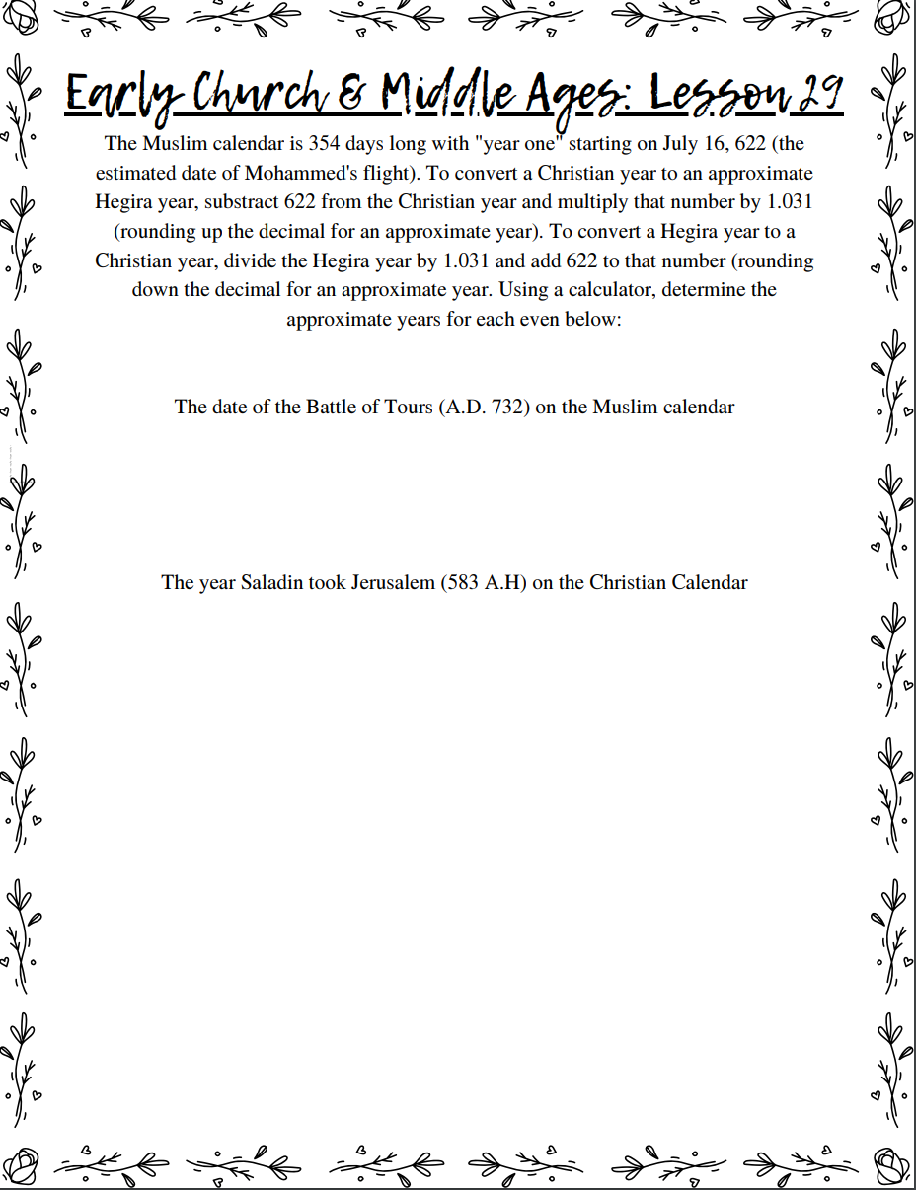
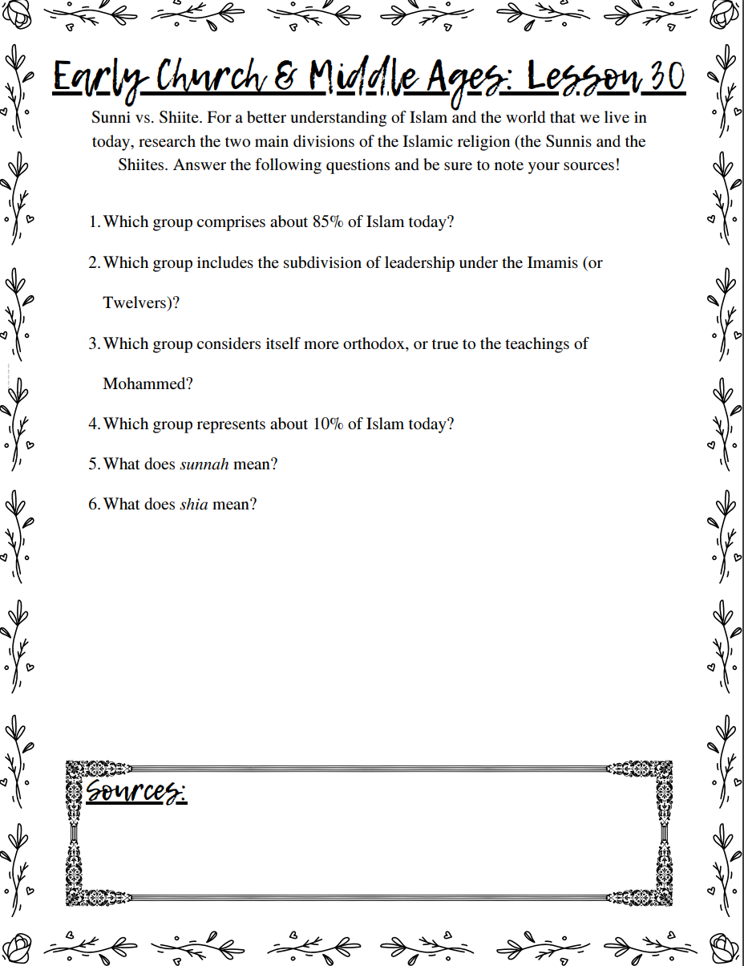
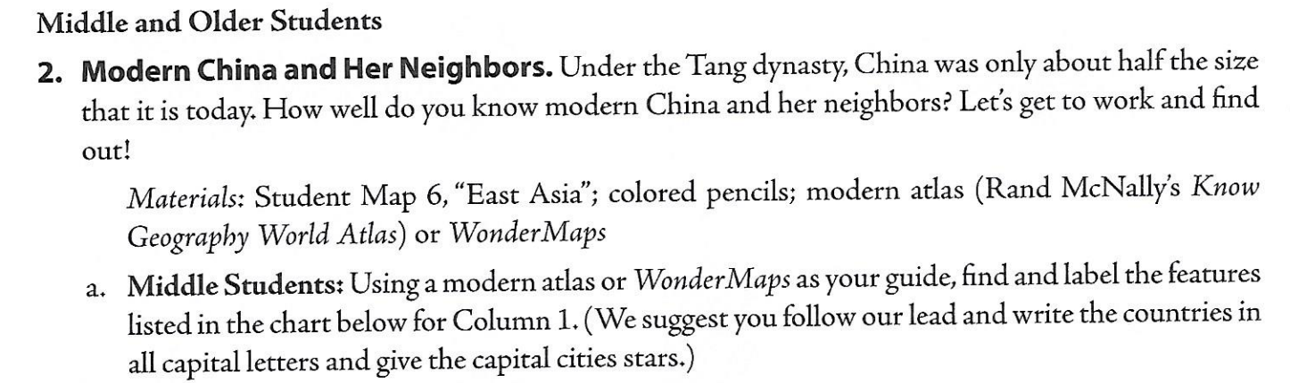
Map Work:
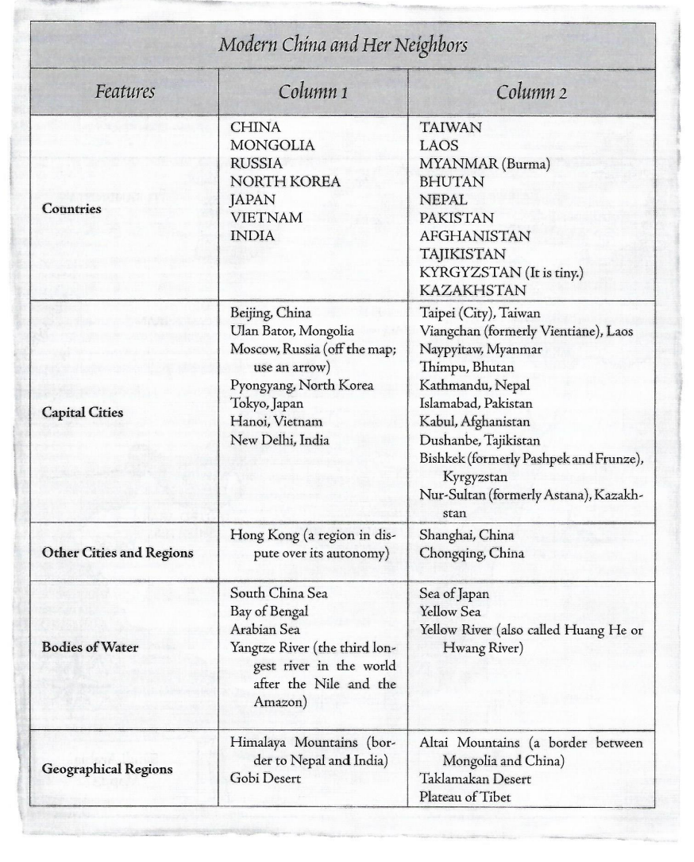

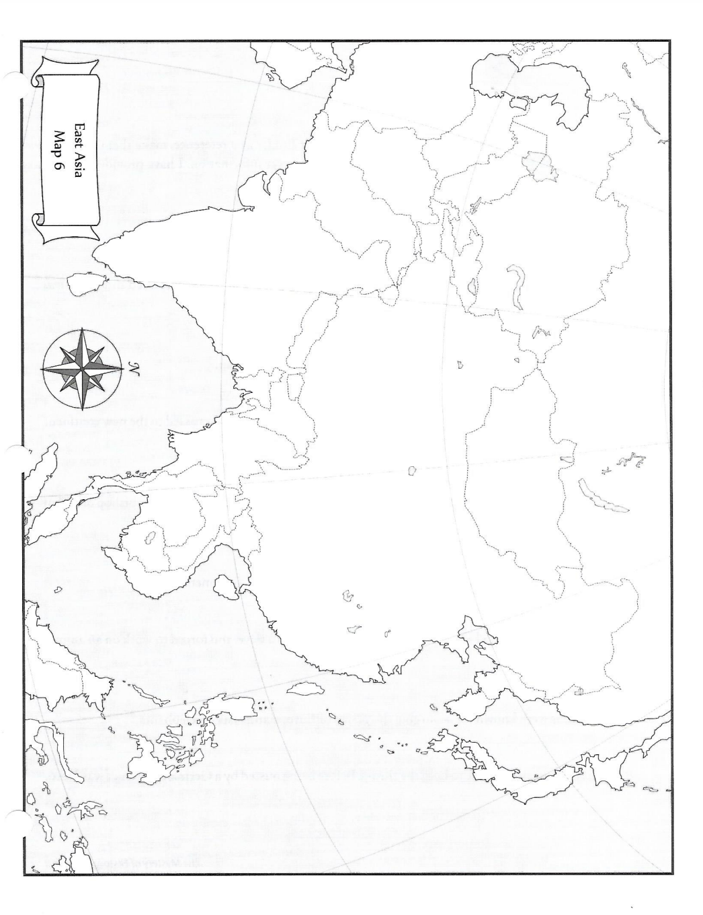
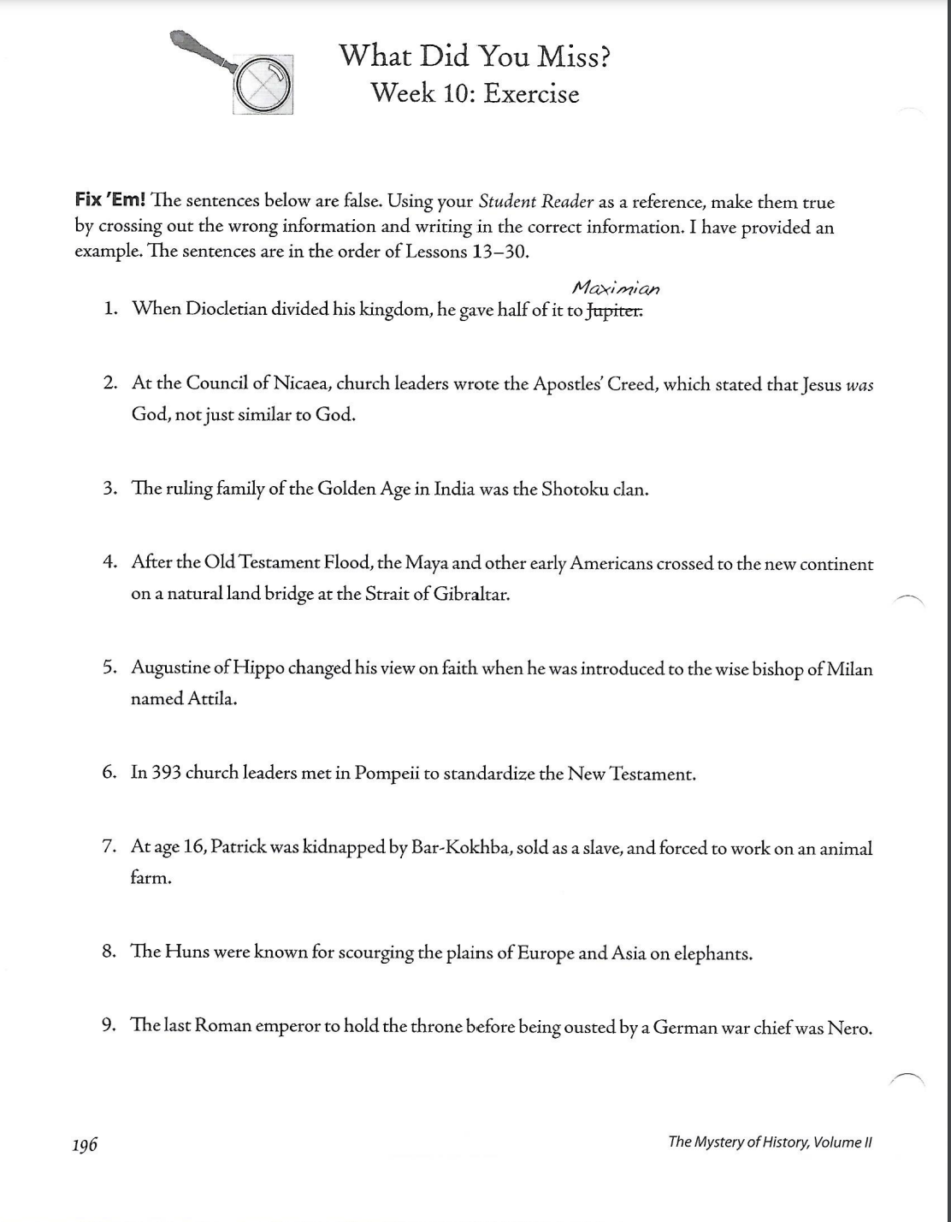
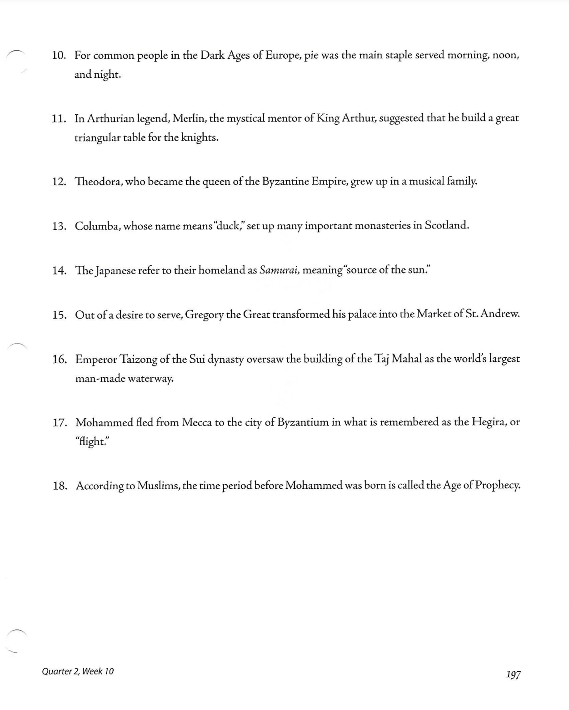
Week 11 Literature
Read “Sir Orfeo”

Orfeo is the shortest piece and tells the story of King Orfeo of Tracience, a famous harp player, who loses his queen, Lady Heurodis, to the Faerie King. He places a steward in his stead and leaves on a ten year journey to win her back. Eventually, he enters the Faerie King’s palace and wins Heurodis by impressing the Faerie King with his harp-playing. When they return, King Orfeo is joyously restored to the throne.

- Make a list of the things that Sir Orfeo must face in his search for Lady Heurodis. This list can reference internal or external conflicts that Sir Orfeo must face. What is the challenge? Is it internal or external? Why is it so difficult? What does Sir Orfeo’s quest for his wife say about him as a character? Your list should consist of several conflicts and challenges.

