Veritas Classical Schools
Jr. High Humanities (Year B) #7
Due 5 October 2022
Mrs. Smith
Junior High Tutor
Desoto IEW & Grammar Tutor
mrssmithatveritas@gmail.com

Bible:
- Finish your study guide for your first bible exam. The test will be given in class next week (10/19/22).
- Begin compiling your summary sheets and cultural corner worksheets from Quarter 1. They will be turned in next week for a homework grade! Be sure to follow all directions presented on each sheet!

Literature:
- Read Chapters 11-15 of When Lightning Struck! The Story of Martin Luther
- Complete the attached discussion questions. Bring worksheet to class and be prepared to discuss your answers!
History:
- Read Lessons 19-21.
- Complete ALL the notebook activity pages and add them to your binder.
- Complete the map work included in this week’s assignment sheet. Please remember that your history notebook will be taken up for a grade in week 8 (10/19/2022). ALL pages assigned through week 7 will be evaluated for content, completion, and neatness.
Logic:
- Read Chapter 7 of The Thinking Tool Box.
- Complete all study questions at the end of the chapter and be prepared for in class discussion.
Vocabulary:
- Complete all the book work in Lesson 4 in Vocabulary from the Classical Roots C.

Parent Signature: _________________________ Student Signature: _____________________________

7th & 8th Old Testament Survey: Study Guide Exam #1

Using COMPLETE sentences, describe the events of each of the seven days of creation:

1.
2.
3.
4.
5.
6.
7.

Vocabulary: Define at least 10 of the following vocabulary words:

Cherubim | Nod | Methuselah | Ziggurat
Sodom | Ishmael | Mt. Moriah | Birthright
Dowry | Dothan | Potiphar | Cupbearer
Signet Ring | Goshen | Bulrushes | Covenant

Essay Questions: Thoroughly answer in complete sentences!

1. Where is the most likely location of the Garden of Eden?
2. How was Seth associated with the flood?
3. What were the two sources of water in the world wide flood?
4. What were the 2 types of biblical covenants?
5. What did Israelites believe about names?
6. Describe the purpose of burnt offerings.
7. What was birthright?
8. Did Esau respect God’s covenants? How did this affect his ancestors?
9. How are birthrights and widowhood connected?
10. Compare and contrast marriage feast and modern weddings
11. How were dreams viewed in ancient times?
12. What was the significance of signet rings?
13. What was a divination cup?

Long Essay:

Summarize your findings from at least two of the following archeological discoveries: The Ebla Tablets, The
Beni-Hasan Tomb Painting, The Mari Tablets, and The Laws of Hammurabi. Carefully explain the history of the discovery and why it is significant to the study of the Old Testament.

Literature: Discussion Questions Chapter 11-15
Name: _____________________________

Directions: Answer the question with a short answer.
Chapter 11:
1. The indulgences Johann Tetzel sold differed from the indulgences the Roman Catholic Church sold in the past. How do you think the change impacted sales?

2. What do you think were some of Martin’s best arguments against indulgences?

Chapter 12:
3. What do you think about how Martin responded to Johann Tetzel’s written rebuttal of the Ninety-Five Theses?

4. Who do you think is the authority for our lives? Do you agree with Martin or with Cajetan?

Chapter 13:
5. How would you react if you expected to die for your faith? How would you feel if someone protected you like Frederick protected Martin?

6. How do you feel about the pope’s actions? Do you think artists and printers responded appropriately to the New Theology?

Chapter 14:

7. How do you feel about Martin’s Address to the Christian Nobility? Should he have asked political leaders for help?

8. How do you feel about Martin’s arguments in Babylonian Captivity of the Church and On the Freedom of a Christian?

Chapter 15:

9. If you were in Martin’s shoes, would you go to Worms? Why or why not?

10. Have you ever taken a stand for what you know to be right based on your conscience? Was it difficult? Do you think it was the right decision?

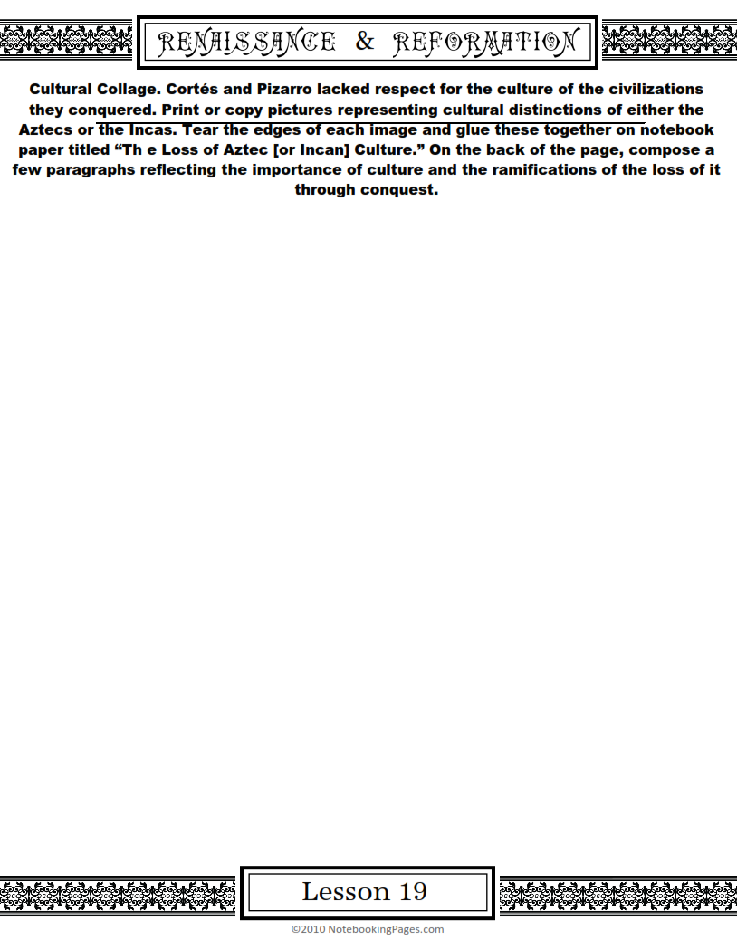
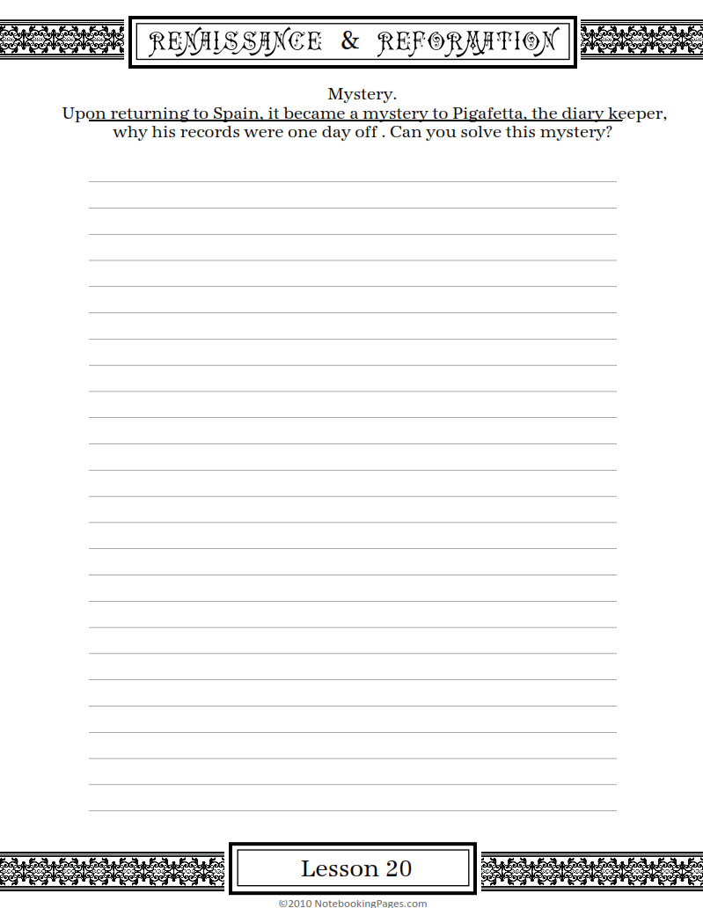
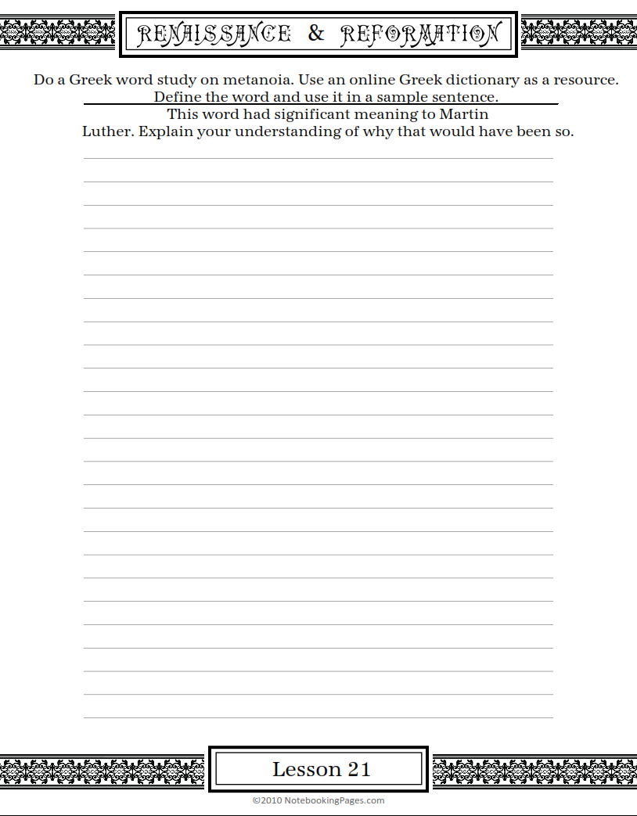
Map Activities:
Find and label the features in Columns A,B, and C of the chart on the next two pages.
Color as desired.

